Praktikum II  
(Pengolahan Citra Digital)

(A3 – A7)

A3

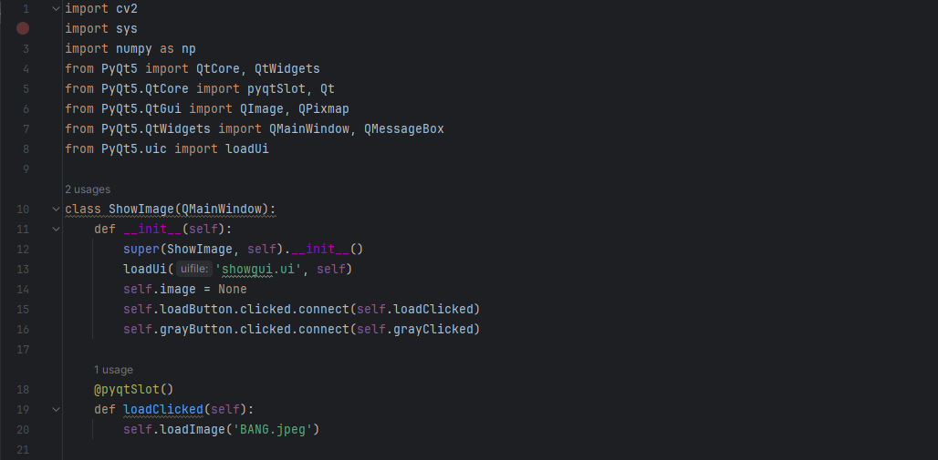

A4

A5

import cv2  
import sys  
import numpy as np  
from PyQt5 import QtCore, QtWidgets  
from PyQt5.QtCore import pyqtSlot, Qt  
from PyQt5.QtGui import QImage, QPixmap  
from PyQt5.QtWidgets import QMainWindow, QMessageBox  
from PyQt5.uic import loadUi  
  
class ShowImage(QMainWindow):  
 def __init__(self):  
 super(ShowImage, self).__init__()  
 loadUi('showgui.ui', self)  
 self.image = None  
 self.loadButton.clicked.connect(self.loadClicked)  
 self.grayButton.clicked.connect(self.grayClicked)  
 self.actionOperasi_Pencerahan.triggered.connect(self.brightness)  
 self.actionSimple_Contrast.triggered.connect(self.contrast)  
  
 @pyqtSlot()  
 def loadClicked(self):  
 self.loadImage('BANG.jpeg')  
  
 def loadImage(self, flname):  
 self.image = cv2.imread(flname)  
 self.displayImage()  
  
 def displayImage(self):  
 qformat = QImage.Format_Indexed8  
  
 if len(self.image.shape) == 3: # row[0], col[1], channel[2]  
 if self.image.shape[2] == 4:  
 qformat = QImage.Format_RGBA8888  
 else:  
 qformat = QImage.Format_RGB888  
  
 img = QImage(self.image.data, self.image.shape[1], self.image.shape[0], self.image.strides[0], qformat)  
 img = img.rgbSwapped()  
  
 self.imgLabel.setPixmap(QPixmap.fromImage(img))  
 self.imgLabel.setAlignment(Qt.AlignHCenter | Qt.AlignVCenter)  
  
 def grayClicked(self):  
 H, W = self.image.shape[:2]  
 gray = np.zeros((H, W), np.uint8)  
 for i in range(H):  
 for j in range(W):  
 gray[i, j] = np.clip(  
 0.299 * self.image[i, j, 0] + 0.587 * self.image[i, j, 1] + 0.114 * self.image[i, j, 2], 0,  
 255)  
 self.image = gray  
 self.displayImage(2)  
  
 def brightness(self):  
 try:  
 self.image = cv2.cvtColor(self.image, cv2.COLOR_BGR2GRAY)  
 except:  
 pass  
  
 H, W = self.image.shape[:2]  
 brightness = 50  
 for i in range(H):  
 for j in range(W):  
 a = self.image.item(i, j)  
 b = np.clip(a + brightness, 0, 255)  
 self.image.itemset((i, j), b)  
  
 self.displayImage(1)  
  
 def contrast(self):  
 try:  
 self.image = cv2.cvtColor(self.image, cv2.COLOR_BGR2GRAY)  
 except:  
 pass  
  
 H, W = self.image.shape[:2]  
 contrast = 1.6  
 for i in range(H):  
 for j in range(W):  
 a = self.image.item(i, j)  
 b = np.clip(a * contrast, 0, 255)  
 self.image.itemset((i, j), b)  
  
 self.displayImage(1)  
 def displayImage(self, window=1):  
 qformat = QImage.Format_Indexed8  
 if len(self.image.shape) == 3:  
 if self.image.shape[2] == 4:  
 qformat = QImage.Format_RGBA8888  
 else:  
 qformat = QImage.Format_RGB888  
 img = QImage(self.image, self.image.shape[1], self.image.shape[0], self.image.strides[0], qformat)  
 img = img.rgbSwapped()  
  
 if window == 1:  
 self.imgLabel.setPixmap(QPixmap.fromImage(img))  
 self.imgLabel.setAlignment(QtCore.Qt.AlignHCenter | QtCore.Qt.AlignVCenter)  
 self.imgLabel.setScaledContents(True)  
  
 if window == 2:  
 self.hasilLabel.setPixmap(QPixmap.fromImage(img))  
 self.hasilLabel.setAlignment(QtCore.Qt.AlignHCenter | QtCore.Qt.AlignVCenter)  
 self.hasilLabel.setScaledContents(True)  
  
app = QtWidgets.QApplication(sys.argv)  
window = ShowImage()  
window.setWindowTitle('Show Image GUI')  
window.show()  
sys.exit(app.exec_())

A6import cv2  
import sys  
import numpy as np  
from PyQt5 import QtCore, QtWidgets  
from PyQt5.QtCore import pyqtSlot, Qt  
from PyQt5.QtGui import QImage, QPixmap  
from PyQt5.QtWidgets import QMainWindow, QMessageBox  
from PyQt5.uic import loadUi  
  
class ShowImage(QMainWindow):  
 def __init__(self):  
 super(ShowImage, self).__init__()  
 loadUi('showgui.ui', self)  
 self.image = None  
 self.loadButton.clicked.connect(self.loadClicked)  
 self.grayButton.clicked.connect(self.grayClicked)  
 self.actionOperasi_Pencerahan.triggered.connect(self.brightness)  
 self.actionSimple_Contrast.triggered.connect(self.contrast)  
 self.actionContrast_Streching.triggered.connect(self.contrastStreching)  
  
 @pyqtSlot()  
 def loadClicked(self):  
 self.loadImage('BANG.jpeg')  
  
 def loadImage(self, flname):  
 self.image = cv2.imread(flname)  
 self.displayImage()  
  
 def displayImage(self):  
 qformat = QImage.Format_Indexed8  
  
 if len(self.image.shape) == 3: # row[0], col[1], channel[2]  
 if self.image.shape[2] == 4:  
 qformat = QImage.Format_RGBA8888  
 else:  
 qformat = QImage.Format_RGB888  
  
 img = QImage(self.image.data, self.image.shape[1], self.image.shape[0], self.image.strides[0], qformat)  
 img = img.rgbSwapped()  
  
 self.imgLabel.setPixmap(QPixmap.fromImage(img))  
 self.imgLabel.setAlignment(Qt.AlignHCenter | Qt.AlignVCenter)  
  
 def grayClicked(self):  
 H, W = self.image.shape[:2]  
 gray = np.zeros((H, W), np.uint8)  
 for i in range(H):  
 for j in range(W):  
 gray[i, j] = np.clip(  
 0.299 * self.image[i, j, 0] + 0.587 * self.image[i, j, 1] + 0.114 * self.image[i, j, 2], 0,  
 255)  
 self.image = gray  
 self.displayImage(2)  
  
 def brightness(self):  
 try:  
 self.image = cv2.cvtColor(self.image, cv2.COLOR_BGR2GRAY)  
 except:  
 pass  
  
 H, W = self.image.shape[:2]  
 brightness = 50  
 for i in range(H):  
 for j in range(W):  
 a = self.image.item(i, j)  
 b = np.clip(a + brightness, 0, 255)  
 self.image.itemset((i, j), b)  
  
 self.displayImage(1)  
  
 def contrast(self):  
 try:  
 self.image = cv2.cvtColor(self.image, cv2.COLOR_BGR2GRAY)  
 except:  
 pass  
  
 H, W = self.image.shape[:2]  
 contrast = 1.6  
 for i in range(H):  
 for j in range(W):  
 a = self.image.item(i, j)  
 b = np.clip(a * contrast, 0, 255)  
 self.image.itemset((i, j), b)  
  
 self.displayImage(1)  
  
 def contrastStreching(self):  
 try:  
 self.image = cv2.cvtColor(self.image, cv2.COLOR_BGR2GRAY)  
 except:  
 pass  
  
 H, W = self.image.shape[:2]  
 minV = np.min(self.image)  
 maxV = np.max(self.image)  
  
 for i in range(H):  
 for j in range(W):  
 a = self.image.item(i, j)  
 b = float(a - minV) / (maxV - minV) * 255  
 self.image.itemset((i, j), b)  
  
 self.displayImage(1)  
  
 def displayImage(self, window=1):  
 qformat = QImage.Format_Indexed8  
 if len(self.image.shape) == 3:  
 if self.image.shape[2] == 4:  
 qformat = QImage.Format_RGBA8888  
 else:  
 qformat = QImage.Format_RGB888  
 img = QImage(self.image, self.image.shape[1], self.image.shape[0], self.image.strides[0], qformat)  
 img = img.rgbSwapped()  
  
 if window == 1:  
 self.imgLabel.setPixmap(QPixmap.fromImage(img))  
 self.imgLabel.setAlignment(QtCore.Qt.AlignHCenter | QtCore.Qt.AlignVCenter)  
 self.imgLabel.setScaledContents(True)  
  
 if window == 2:  
 self.hasilLabel.setPixmap(QPixmap.fromImage(img))  
 self.hasilLabel.setAlignment(QtCore.Qt.AlignHCenter | QtCore.Qt.AlignVCenter)  
 self.hasilLabel.setScaledContents(True)  
  
app = QtWidgets.QApplication(sys.argv)  
window = ShowImage()  
window.setWindowTitle('Show Image GUI')  
window.show()  
sys.exit(app.exec_())

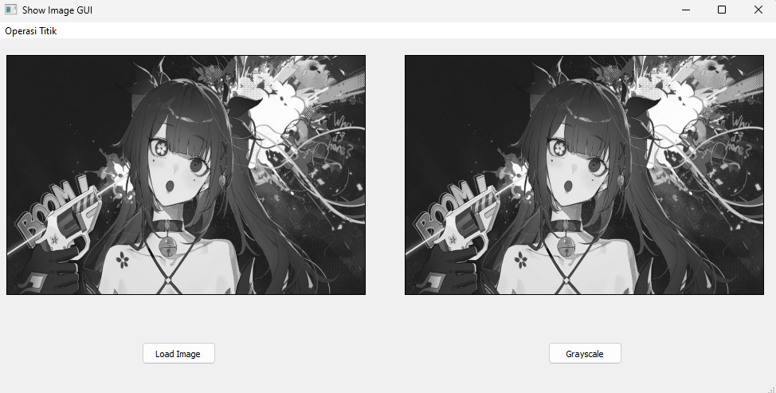

A7

import cv2  
import sys  
import numpy as np  
from PyQt5 import QtCore, QtWidgets  
from PyQt5.QtCore import pyqtSlot, Qt  
from PyQt5.QtGui import QImage, QPixmap  
from PyQt5.QtWidgets import QMainWindow, QMessageBox  
from PyQt5.uic import loadUi  
  
class ShowImage(QMainWindow):  
 def __init__(self):  
 super(ShowImage, self).__init__()  
 loadUi('showgui.ui', self)  
 self.image = None  
 self.loadButton.clicked.connect(self.loadClicked)  
 self.grayButton.clicked.connect(self.grayClicked)  
 self.actionOperasi_Pencerahan.triggered.connect(self.brightness)  
 self.actionSimple_Contrast.triggered.connect(self.contrast)  
 self.actionContrast_Streching.triggered.connect(self.contrastStreching)  
 self.actionNegative_Image.triggered.connect(self.negativeImage)  
  
 @pyqtSlot()  
 def loadClicked(self):  
 self.loadImage('BANG.JPEG')  
  
 def loadImage(self, flname):  
 self.image = cv2.imread(flname)  
 self.displayImage()  
  
 def displayImage(self):  
 qformat = QImage.Format_Indexed8  
  
 if len(self.image.shape) == 3: # row[0], col[1], channel[2]  
 if self.image.shape[2] == 4:  
 qformat = QImage.Format_RGBA8888  
 else:  
 qformat = QImage.Format_RGB888  
  
 img = QImage(self.image.data, self.image.shape[1], self.image.shape[0], self.image.strides[0], qformat)  
 img = img.rgbSwapped()  
  
 self.imgLabel.setPixmap(QPixmap.fromImage(img))  
 self.imgLabel.setAlignment(Qt.AlignHCenter | Qt.AlignVCenter)  
  
 def grayClicked(self):  
 H, W = self.image.shape[:2]  
 gray = np.zeros((H, W), np.uint8)  
 for i in range(H):  
 for j in range(W):  
 gray[i, j] = np.clip(  
 0.299 * self.image[i, j, 0] + 0.587 * self.image[i, j, 1] + 0.114 * self.image[i, j, 2], 0,  
 255)  
 self.image = gray  
 self.displayImage(2)  
  
 def brightness(self):  
 try:  
 self.image = cv2.cvtColor(self.image, cv2.COLOR_BGR2GRAY)  
 except:  
 pass  
  
 H, W = self.image.shape[:2]  
 brightness = 50  
 for i in range(H):  
 for j in range(W):  
 a = self.image.item(i, j)  
 b = np.clip(a + brightness, 0, 255)  
 self.image.itemset((i, j), b)  
  
 self.displayImage(1)  
  
 def contrast(self):  
 try:  
 self.image = cv2.cvtColor(self.image, cv2.COLOR_BGR2GRAY)  
 except:  
 pass  
  
 H, W = self.image.shape[:2]  
 contrast = 1.6  
 for i in range(H):  
 for j in range(W):  
 a = self.image.item(i, j)  
 b = np.clip(a * contrast, 0, 255)  
 self.image.itemset((i, j), b)  
  
 self.displayImage(1)  
  
 def contrastStreching(self):  
 try:  
 self.image = cv2.cvtColor(self.image, cv2.COLOR_BGR2GRAY)  
 except:  
 pass  
  
 H, W = self.image.shape[:2]  
 minV = np.min(self.image)  
 maxV = np.max(self.image)  
  
 for i in range(H):  
 for j in range(W):  
 a = self.image.item(i, j)  
 b = float(a - minV) / (maxV - minV) * 255  
 self.image.itemset((i, j), b)  
  
 self.displayImage(1)  
  
 def negativeImage(self):  
 if self.image is not None:  
 negative_img = 255 - self.image  
 self.image = negative_img  
 self.displayImage()  
  
 def displayImage(self, window=1):  
 qformat = QImage.Format_Indexed8  
 if len(self.image.shape) == 3:  
 if self.image.shape[2] == 4:  
 qformat = QImage.Format_RGBA8888  
 else:  
 qformat = QImage.Format_RGB888  
 img = QImage(self.image, self.image.shape[1], self.image.shape[0], self.image.strides[0], qformat)  
 img = img.rgbSwapped()  
  
 if window == 1:  
 self.imgLabel.setPixmap(QPixmap.fromImage(img))  
 self.imgLabel.setAlignment(QtCore.Qt.AlignHCenter | QtCore.Qt.AlignVCenter)  
 self.imgLabel.setScaledContents(True)  
  
 if window == 2:  
 self.hasilLabel.setPixmap(QPixmap.fromImage(img))  
 self.hasilLabel.setAlignment(QtCore.Qt.AlignHCenter | QtCore.Qt.AlignVCenter)  
 self.hasilLabel.setScaledContents(True)  
  
app = QtWidgets.QApplication(sys.argv)  
window = ShowImage()  
window.setWindowTitle('Show Image GUI')  
window.show()  
sys.exit(app.exec_())

